**IFB299 Personal Portfolio**

**Group 27**

**Name: SiuLun Wong**

**Student No.: n8502536**

**Artefact1 – User Stories**

Before starting sprint 1, the whole group helped brainstorming and developing user stories. All the user stories were put on the JIRA by another member and my responsibility was to add description and estimate the story point to each user story. After sprint 1 and getting feedback for the user stories from the tutor, we had to make changes to some of our user stories and add some new user stories in order to make sprint 2 easier to implement and facilitates the website. Mitchell, Yuan and I fixed the user stories and my responsibility was to add description for them, defined the priority of them and sorted them into sprint 2/3/4.

**Artefact 2 – Database Design**

During Sprint 1, a database is needed for creating user account. Mitchell and I developed the structure of the database for the website. There were 3 tables in total which are users, PropertyListing and gallery. The users table stores all the details of a user including name, mobile number and email etc. PropertyListing table stores the details of the property including address and price. Gallery table stores the image of each property which is linked to the PropertyListing table. Each field in each table has different data types and a primary key was introduced. The entity relationship between three tables was established as well. The implementation was completed by Mitchell using SQLlite and can be found in GitHub. The database was significant to the website as it is the crucial element for basis of development because further accounts could be created once the database is well set up.

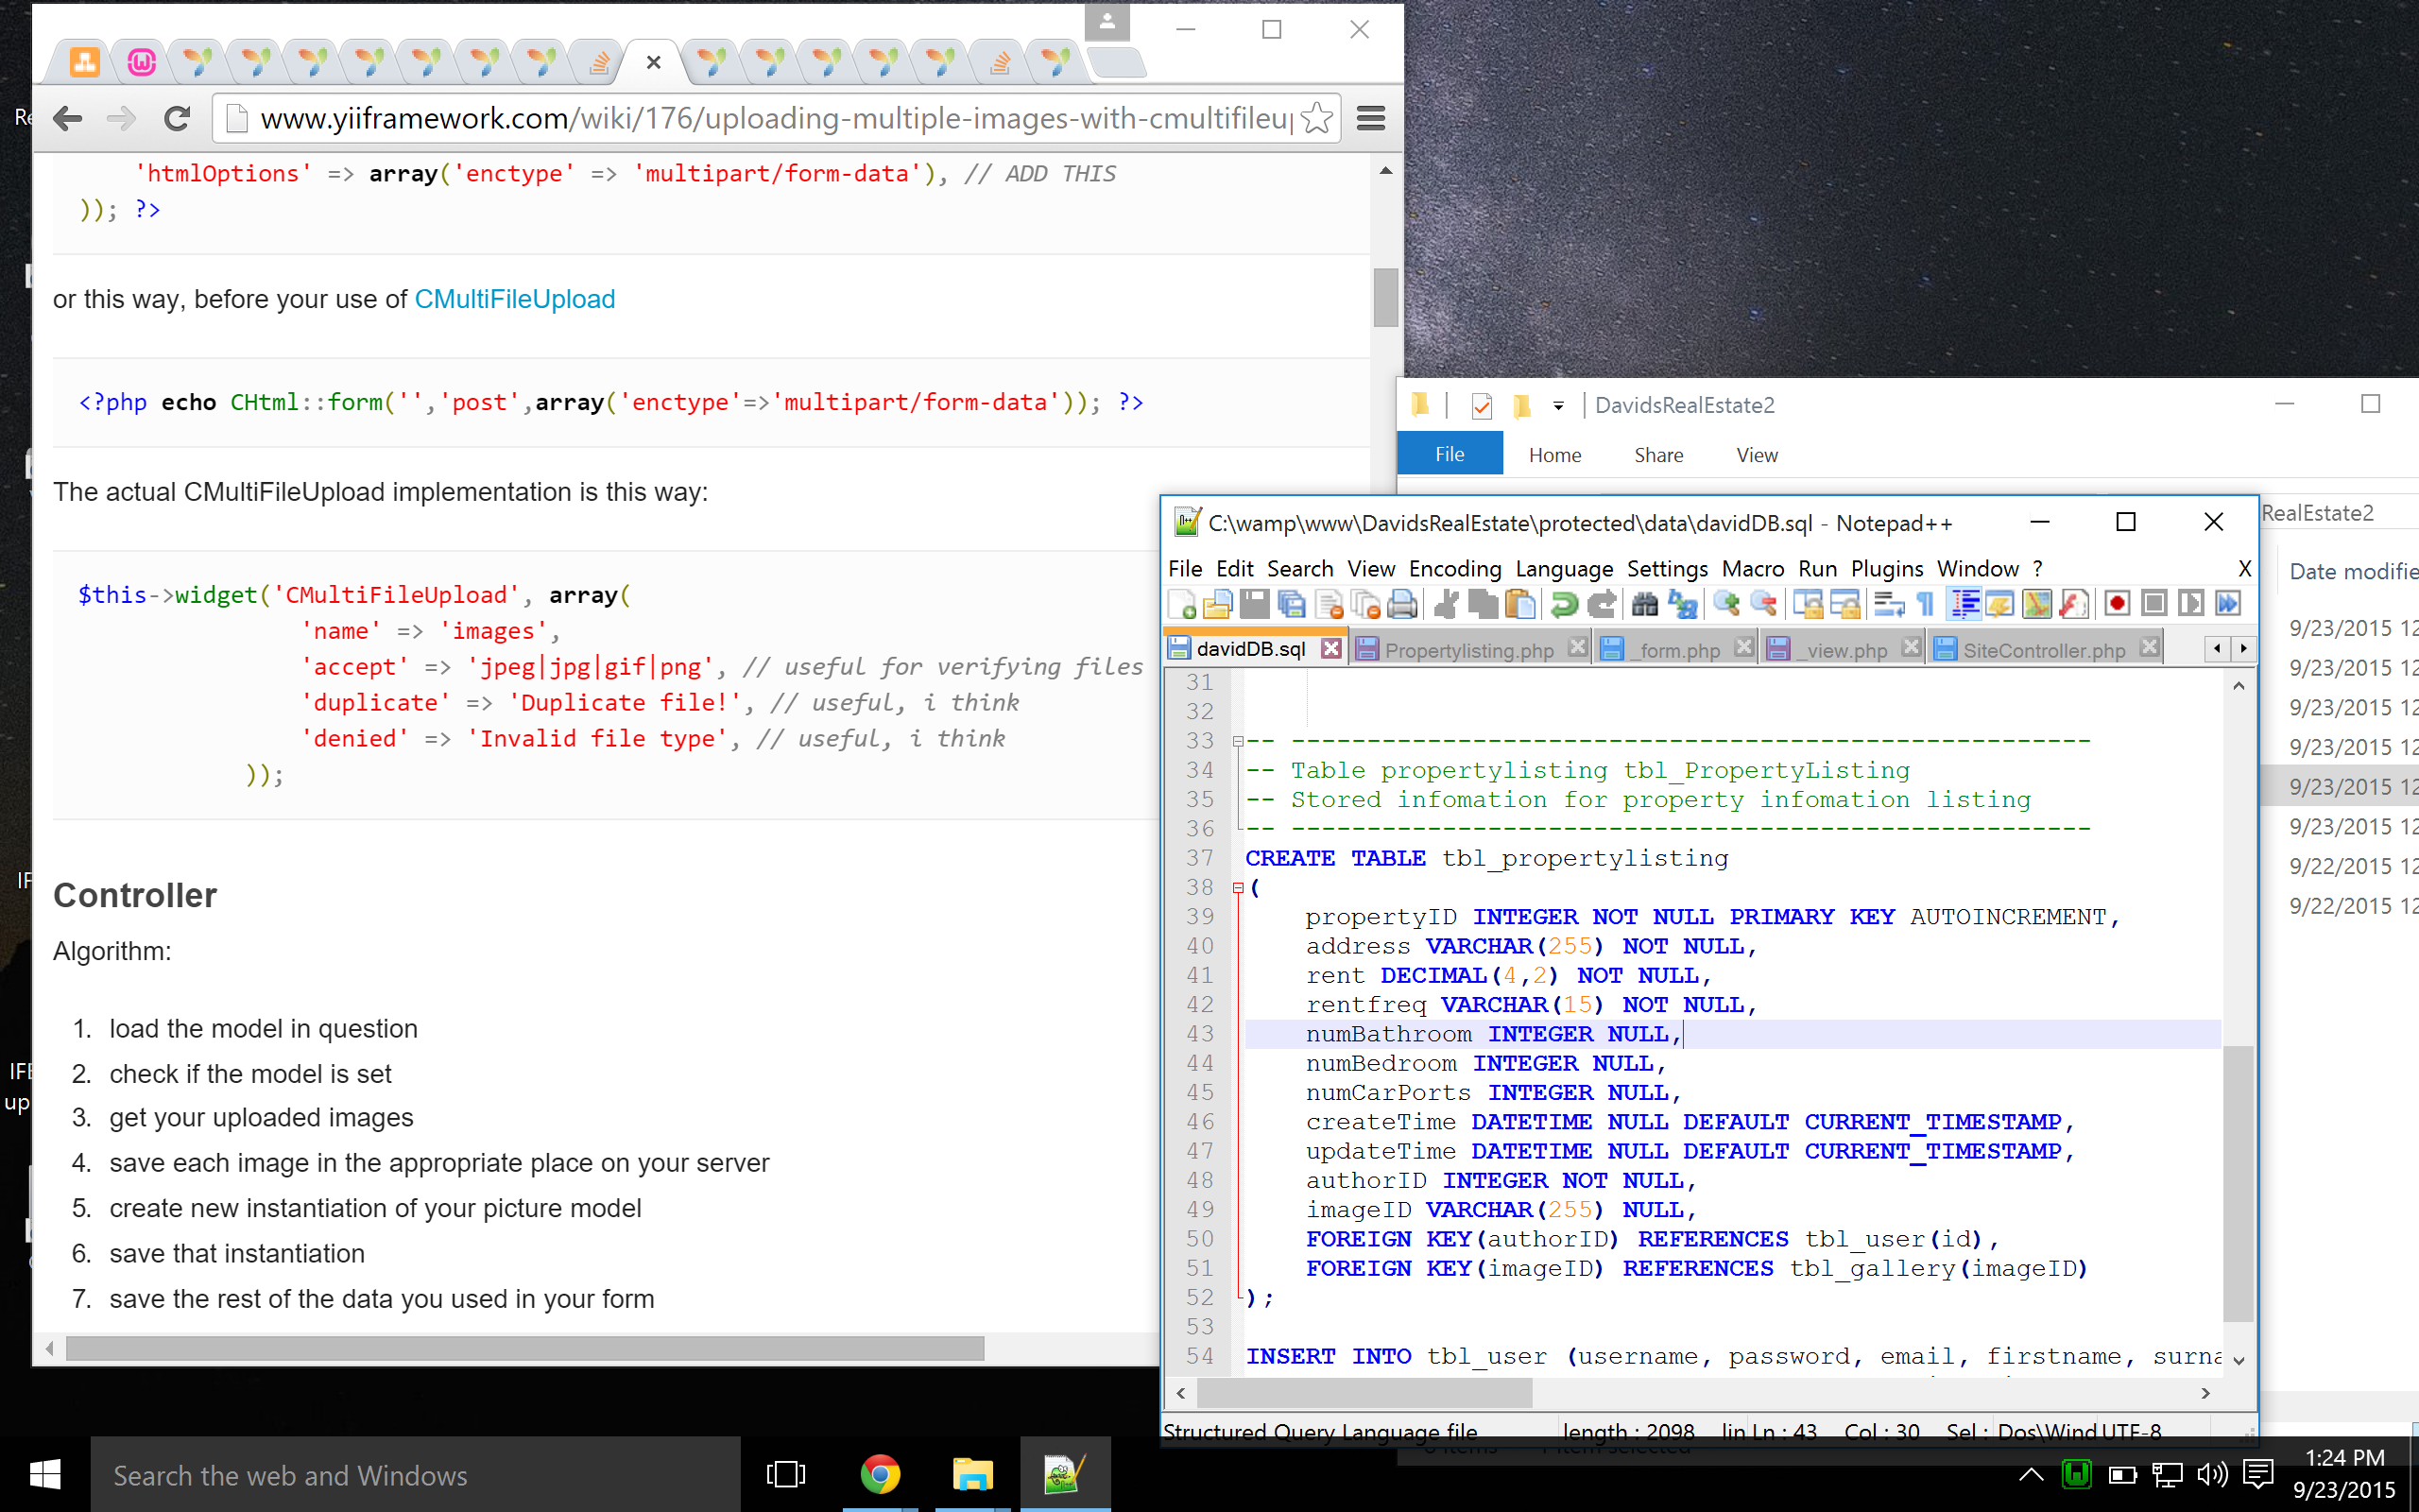

***Personally I had problem uploading or committing work I have done to GitHub every time I finished a feature. Therefore, for the coding side of work, I sent them off to Mitchell and let him put them on GitHub for me.

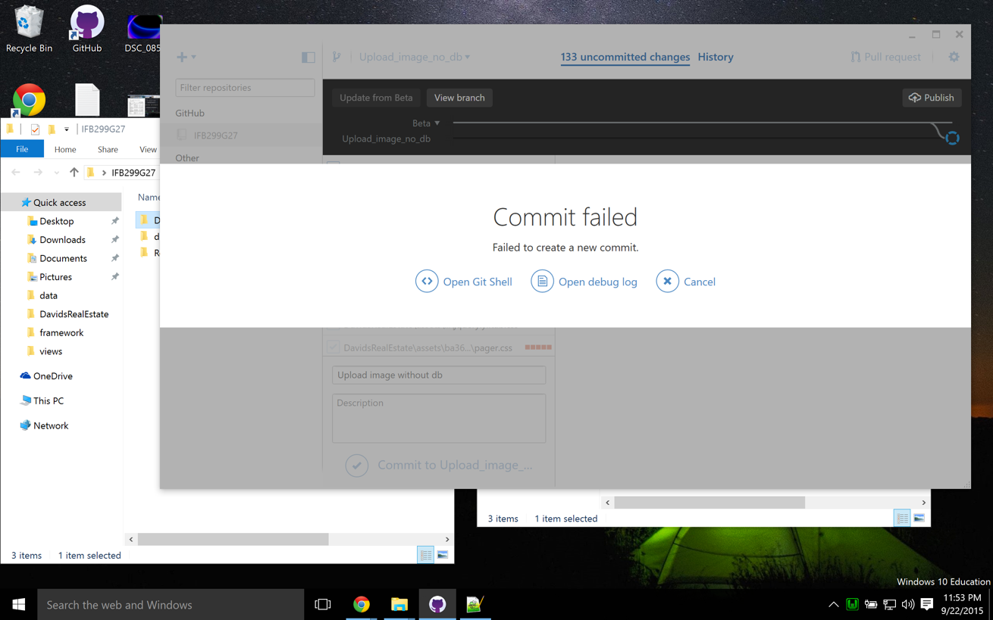

**Artefact 3 – Upload image for Property**

This is a user story in Sprint 2 which is to able the upload image function when creating property listing. When users create a property listing, they should be able to upload images for that property so that the images will be stored in the database. This is the main feature of sprint 2 as other main fields for creating property listing had all been implemented in sprint 1. This was added by modifying controller, _form.php and PropertyListing model and added some codes to able this feature. This is also an important feature because a property manager would like to add some photos for customers to see how the property looks like and it also has 3 story points which is considered relatively important.

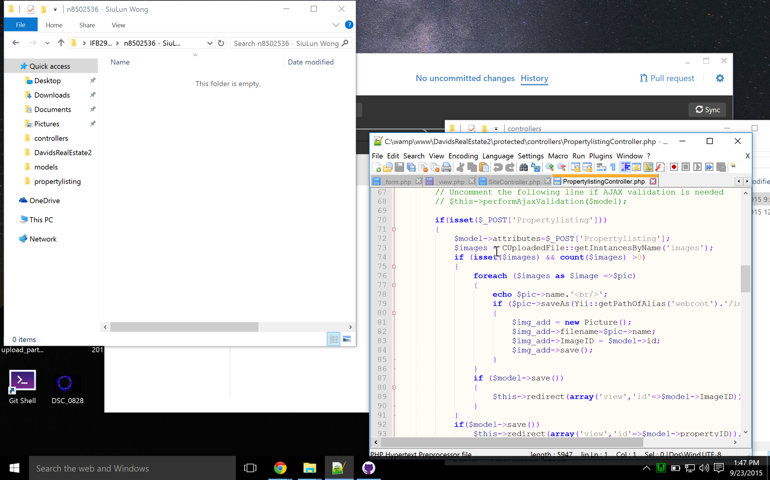

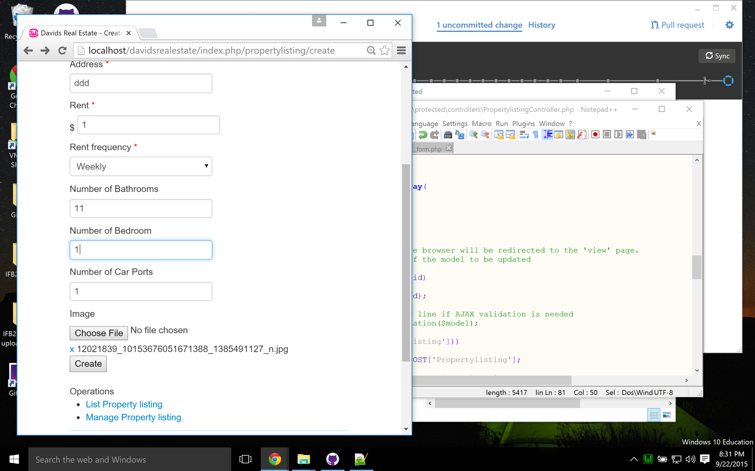

**Artefact 4 – Display image for Property**

This is a follow up of the previous artefact which is allow to display the image of a property on the website and view the image for a property listing from a guest’s point of view. When users successfully uploaded images for a property listing, the listing should be updated with images retrieved from the database to display. This is important to make the website appealing to attract potential customers.

**Artefact 5 – Create listing feature**

This is a main feature of the website which allows admin and property manager to create property listing posts on the website. This is partly done by me and the rest was done by Mitchell. This feature is very important as this is the main point of the website. The property listing details will be saved to the database propertylisting table and can be retrieved and displayed on the property listing page. There are several fields and a propertyID will be automatically generated for each listing. This can be shown in the screenshot for upload photo feature.